Bingo: Taxonomy Profile
Taxonomy Factor | Classification
Name | Bingo. Representative title: Bingo Blitz (Playtika). Real-money variant: Bingo Cash (Papaya Gaming)
Candidate Class | Social-casino apps (free-to-play, purchasable virtual currency). The real-money variant is a skill-cash contest app
Primary Audience | Adults, including older adults. The Washington Attorney General alleges that children also play on parents' phones
Gambling Connection | High (simulated). Bingo is a chance game, and virtual currency bought with real money is staked on it; winnings are not cashable
Addiction / Harm Score | 7/10: High
Risk Score | 6/10: Moderate to High
Tier Classification | T2: paid random draw, no cash-out (Bingo Blitz). Bingo Cash: T4/T5 boundary
Financial Score | 7/10: High
Monetary Value | Virtual currency bought with real money; winnings are credited as more virtual currency inside the app. Bingo Cash: cash entry fee in, cash prize out
Regulatory Status | Bingo Blitz: named in the Washington Attorney General's lawsuit (3 February 2026) alleging unlicensed gambling; these are allegations, and the case was still before the court in July 2026 (Washington State Office of the Attorney General, 2026; KOMO News, 2026). Australia requires R18+ for simulated gambling (Australian Classification Board, 2024). Bingo Cash: Papaya US$15M player class settlement with no admission of wrongdoing (ClassAction.org, 2025); a separate federal jury found in April 2026 that Papaya used undisclosed bots in games marketed as skill-based, and a US$719M judgment was entered in July 2026 (Perkins Coie, 2026; Takahashi, 2026).

1. Bingo
Bingo Blitz is a free-to-download bingo app published by Playtika. It is one of 16 casino-style apps named in the Washington Attorney General's 2026 lawsuit. It features a blue cartoon cat called Blitzy, a pink mouse called Moxie, a travel map with a photo album, and a linked YouTube channel (Washington State Office of the Attorney General, 2026). Bingo Cash is a separate real-money app from Papaya Gaming, which also makes Solitaire Cash, Bubble Cash, and 21 Cash (ClassAction.org, 2025).

2. Description and Connection to Gambling
Players buy virtual currency and use it to play bingo rounds for the chance of winning more virtual currency. The Washington State Attorney General's February 2026 lawsuit lists Bingo Blitz among 16 apps run by Playtika and Aristocrat and alleges that these are unlicensed gambling under Washington law and that the apps bank winnings inside the app, so the only way to use them is to keep playing (Washington State Office of the Attorney General, 2026). They are claims rather than established findings, and the characterisation of the games is disputed. One former chair of the Nevada Gaming Control Board said free-to-play apps that give no money or redeemable prize should be considered social entertainment (KOMO News, 2026).
Bingo Cash (Papaya Gaming) is a separate product using the same label. Players pay a fee to enter cash contests which are advertised as skill contests (ClassAction.org, 2025; Skillz, n.d., for the vendor’s description of the skill-contest model).
High (simulated) Gambling Connection: This is similar to gambling because people stake purchased currency on uncertain results. The difference from a casino is that the winnings are not paid out in cash.

3. Age Group and Addiction Risk
Primary age group: Adults, including older adults. A scoping review of gambling products and older adults (Johnson et al., 2023) revealed that the products themselves are virtually unstudied, while an ad-tech vendor’s glossary indicates that people over 50 typically spend the longest time playing social-casino games (adjoe, 2025; this is an industry claim, not independent research). The Washington complaint alleges that Bingo Blitz uses cartoon cats and children's-television-style content, that none of the 16 apps ask for a player's age, and that parents report children spending hundreds of dollars on their phones (Washington State Office of the Attorney General, 2026). Australian rules require simulated gambling to be classified R18+ (Australian Classification Board, 2024).
Addiction / Harm Score: 7/10: High. Documented or alleged mechanics:
- Purchased currency staked on chance outcomes. Players buy virtual currency and wager it in rounds (Washington State Office of the Attorney General, 2026).
- Winnings that stay in the app. As alleged, winnings are banked so the player's only use for them is further play (Washington State Office of the Attorney General, 2026).
- Child-appealing presentation. Cartoon characters and a photo-album collection are alleged to be filled by playing bingo on a travel map (Washington State Office of the Attorney General, 2026).
Among at-risk gamblers who played social-casino games, greater frequency, variety, and spending were associated with more symptoms of problematic use (Gainsbury et al., 2017). The score is a taxonomy assessment, not a clinical diagnosis.

4. Risk or Danger
Risk Level: Moderate to High: 6/10.
- Litigation and regulatory exposure. Washington's February 2026 suit follows a 2020 Playtika class-action settlement of US$38 million over claims under Washington law (Washington State Office of the Attorney General, 2026). The outcome of the 2026 case was not established in the sources reviewed.
- Age-assurance gap (alleged). No age or date of birth is requested before play, and the 21-and-older term sits outside the app (Washington State Office of the Attorney General, 2026; KOMO News, 2026).
- Deceptive contest design in Bingo Cash. Papaya agreed to a US$15 million settlement of claims that Bingo Cash, Solitaire Cash and other games used undisclosed bots in contests marketed as skill-based; the class covered deposits from 1 January 2019 to 5 September 2024, and the company did not admit wrongdoing (ClassAction.org, 2025). In the separate federal case brought by Skillz, a jury found in April 2026 that Papaya had used undisclosed bots in games marketed as fair and skill-based, and judgment was entered on 28 July 2026 (Perkins Coie, 2026; Regulatory Oversight, 2026): US$719 million in disgorgement in place of the jury's US$420 million, which Papaya may appeal (Takahashi, 2026). The sources consulted do not indicate the specific Papaya titles that the verdict refers to, so it is indicated here as evidence regarding Papaya’s practices in general.

5. Tier Classification
Tier: T2: Paid Random Draw, No Cash-out (Bingo Blitz).
Classification path (Bingo Blitz):
Bingo Blitz → virtual currency purchased using real money → bingo games based on chance → virtual currency won through play → no cash-out option → T2
Path to Classification (Bingo Cash):
Proceeds from the bingo entry fee go into a skill-contest bingo that pays out cash, with T4/T5 boundary proceeds going to Bingo Cash.
For the taxonomy: Both Bingo Blitz and Zynga Poker (Cards profile) have the same class and tier. They make a logical pair for the inter-rater exercise, as two coders should be able to classify them at the same tier based on the rule alone.

6. Harm: Financial Harm and Psychological Harm
Financial Score: 7/10: High
Financial harm. Since September 2020, Washington players are reported to have made over 8 million purchases on Playtika apps, spending over US$151 million. The Attorney General states that some individuals lost hundreds of thousands of dollars across the 16 apps (KOMO News, 2026; Washington State Office of the Attorney General, 2026). Because the winnings cannot be converted into cash, each purchase remains a cost to the player. Langham et al. (2016) categorise financial harm as one of seven types of harm.
Psychological harm. Playing to escape a negative mood is the most common symptom of problematic social-casino use, and greater psychological distress was linked to more severe problems (Gainsbury et al., 2017). When children access the app, their exposure to simulated gambling becomes a harm concern raised in the Washington complaint.

7. Monetary Value
Monetary Value: No cash out (closed-loop virtual currency) and Bingo Cash pays out cash prizes.
Cash-out pathways:
- Bingo Blitz: money → virtual money → playing bingo → virtual currency that can be won. The complaint is for banked inside the app (Washington State Office of the Attorney General, 2026).
- Bingo Cash: cash entry fee → contest → cash prize paid to winners (ClassAction.org, 2025).

8. Evidence as Images
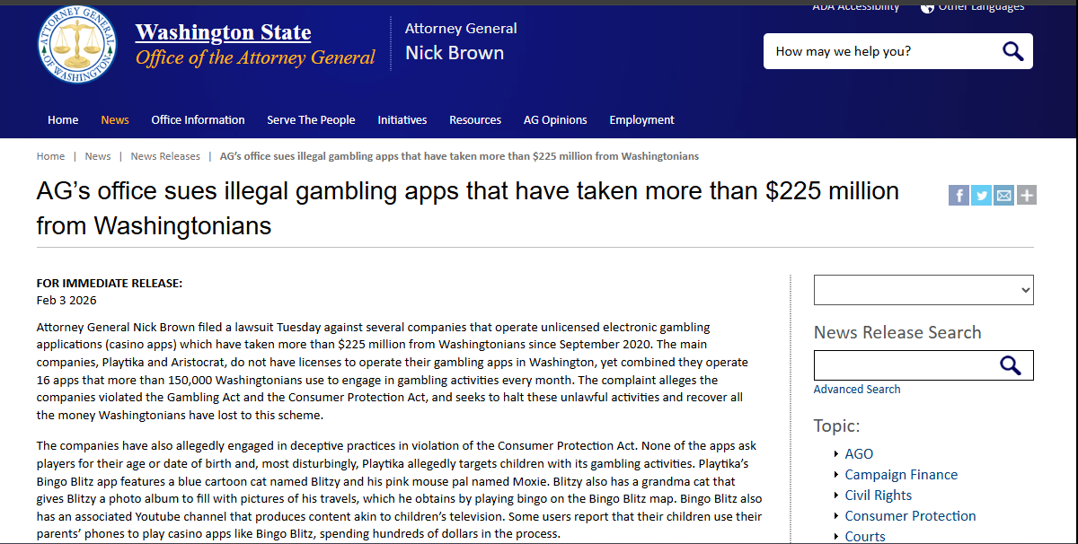 | 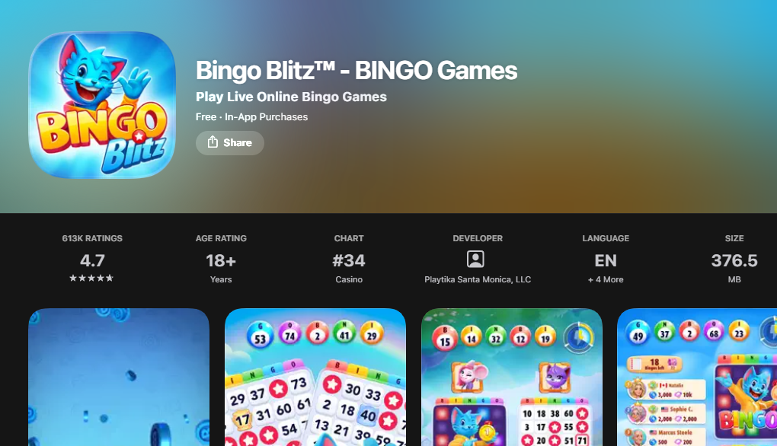
Figure 9: Washington Attorney General news release (3 February 2026) describing Bingo Blitz, Blitzy and Moxie | Figure 10: Bingo Blitz App Store listing showing a free download with in-app purchases and an 18+ age rating
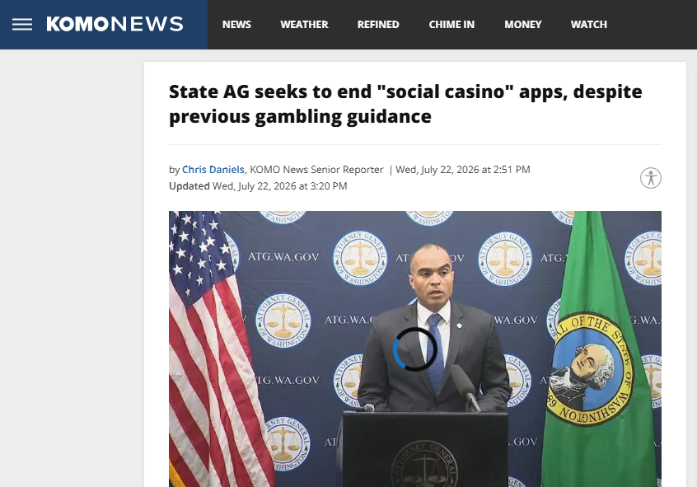 | 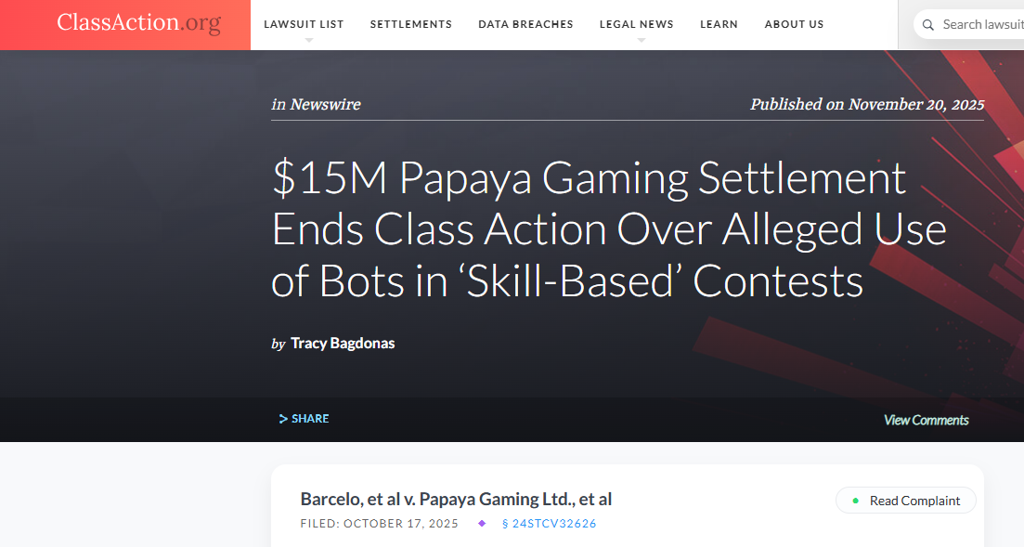
Figure 11: KOMO News article (22 July 2026) on the lawsuit against social casino apps | Figure 12: ClassAction.org page for the Papaya Gaming settlement (Barcelo v. Papaya Gaming)

9. References
adjoe. (2025, July 21). Social casino games: Definition, types & demographics. https://adjoe.io/glossary/social-casino-games-defined/
Australian Classification Board. (2024). New classifications for gambling-like content in video games. https://www.classification.gov.au/about-us/media-and-news/news/new-classifications-for-gambling-content-video-games
ClassAction.org. (2025, November 20). $15M Papaya Gaming settlement ends class action over alleged use of bots in "skill-based" contests. https://www.classaction.org/news/15m-papaya-gaming-settlement-ends-class-action-over-alleged-use-of-bots-in-skill-based-contests
Gainsbury, S. M., King, D. L., Russell, A. M. T., Delfabbro, P., & Hing, N. (2017). Virtual addictions: An examination of problematic social casino game use among at-risk gamblers. Addictive Behaviors, 64, 334–339. https://doi.org/10.1016/j.addbeh.2015.12.007
Johnson, R. H., Pitt, H., Randle, M., & Thomas, S. L. (2023). A scoping review of the individual, socio-cultural, environmental and commercial determinants of gambling for older adults: Implications for public health research and harm prevention. BMC Public Health, 23, Article 362. https://doi.org/10.1186/s12889-022-14930-y
KOMO News. (2026, July 22). State AG seeks to end "social casino" apps, despite previous gambling guidance. https://komonews.com/news/local/state-ag-seeks-to-end-social-casino-apps-despite-previous-gambling-guidance-washington-state-gambling-commission-playtika-bingo-blitz-big-fish-casino-currency
Langham, E., Thorne, H., Browne, M., Donaldson, P., Rose, J., & Rockloff, M. (2016). Understanding gambling related harm: A proposed definition, conceptual framework, and taxonomy of harms. BMC Public Health, 16, Article 80. https://doi.org/10.1186/s12889-016-2747-0
Perkins Coie. (2026, June 17). Skillz v. Papaya Gaming: Record Lanham Act verdict puts bots, matchmaking, and "skill-based" marketing on trial. https://perkinscoie.com/insights/update/skillz-v-papaya-gaming-record-lanham-act-verdict-puts-bots-matchmaking-and-skill
Regulatory Oversight. (2026, July 31). When "skill-based" isn't: The Papaya Gaming verdict and its implications for mobile gaming operators. https://www.regulatoryoversight.com/2026/07/when-skill-based-isnt-the-papaya-gaming-verdict-and-its-implications-for-mobile-gaming-operators/
Skillz. (n.d.). The legality of skill gaming [Vendor documentation]. https://docs.skillz.com/docs/legal-skillz/
Takahashi, D. (2026, July 28). Skillz (now Firy) wins $719M judgment against Papaya Gaming in largest false advertising award in history. GamesBeat. https://gamesbeat.com/skillz-now-firy-wins-719m-judgment-against-papaya-gaming-in-largest-false-advertising-award-in-history/
Washington State Office of the Attorney General. (2026, February 3). AG's office sues illegal gambling apps that have taken more than $225 million from Washingtonians [News release]. https://www.atg.wa.gov/news/news-releases/ag-s-office-sues-illegal-gambling-apps-have-taken-more-225-million

